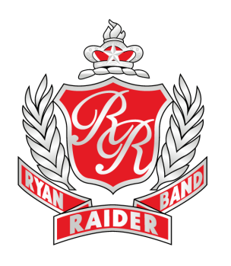

**OCTOBER 20, 2018 – UIL REGION 2 MARCHING BAND CONTEST**

**NORTHWEST ISD STADIUM**

**1937 TEXAN DR. JUSTIN, TX 76247**

***Subject to Change***

**Itinerary:**

9:15am Band Hall Opens

9:45-10:45am Rehearsal

11:00am Eat lunch. Lunch provided!

12:00pm Load Trailer

12:45pm Inspection: Alter Ego shirt, blue RRB shorts, marching shoes, solid black socks (calf length, no designs), uniform in garment bag

1:15pm Line up for buses

1:30pm Depart RHS

2:30pm Arrive at Northwest ISD Stadium

2:45pm Unload trailer. Put on uniforms.

3:30pm Full band meeting and inspection at trailer in full uniform with hats

4:00-4:25pm Warm-up time slot

4:30pm Band reports at field

4:45pm UIL performance

5:00pm Load Trailer

5:20pm Listen to bands

5:45pm Results

6:00pm Leave Northwest ISD Stadium

7:00pm Arrive at RHS

**What to bring:**

* Attire for uniform (see Inspection above)
* Camelbak for water (you will be able to refill at our trailer)
* Money if you plan to purchase concessions or souvenirs (UIL patches sold)

**Other details:**

This is one of the most significant performances of the first semester for the band program because it determines our school’s UIL band rating for 2018-19.

Students please get plenty of rest and eat a good breakfast before coming to RHS. You are well prepared for this contest and we are confident you will be able to achieve your goal! Please contact the directors if you have any questions.

Go Band!

Mary Brown

**Ryan High School**

**“Home of Champions”**

5101 E. McKinney St.

Denton, Texas 76208

Fax 940-369-4960

**Raider Band Website**

www.dentonisd.org/raiderband

**Mary Brown**

Director of Bands

940-369-3079

mbrown@dentonisd.org

**Juan Nuñez**

Associate Director of Bands

940-369-3049

jnunez@dentonisd.org

**Akira Robles**

Director of Percussion

940-369-3078

arobles2@dentonisd.org