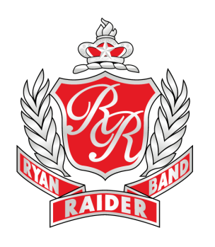

**OCTOBER 13, 2018 – DON HANNA MEMORIAL MARCHING BAND CONTEST**

**DENTON ISD C.H. COLLINS ATHLETIC COMPLEX**

Our band and booster club are hosting this contest. **We need many students and parents volunteering for the variety of jobs necessary to make this contest a success.** Students will start and end at Collins Stadium. Do not meet at RHS. All student workers must wear their “Home of Champions” Raider Band Shirt.

**WE ARE PERFORMING IN THIS CONTEST. EVERY BAND STUDENT WILL FOLLOW THE PERFORMANCE SCHEDULE BELOW REGARDLESS OF HIS/HER VOLUNTEER SHIFT TIME**

***RHS Performance Schedule:***

*6:45am Meet at band trailer in home side parking lot. Unload equipment and get dressed into uniform with Blue RRB shirt, blue RRB shorts, marching shoes, solid black socks (calf length).*

*7:30am Inspection at trailer. Full uniform.*

*7:45- 8:15am Warm-up time slot (Area A)*

*8:20am Band reports at field entry gate*

*8:30am Performance*

*8:45am Load equipment onto trailer. Hang uniform on hanger in garment bag.*

Following our performance, students are free to go unless they are signed up to work immediately after that. ***All students must participate in a working shift for this day.***

**What to bring:**

* Attire for uniform: Blue RRB shirt, RRB shorts, solid black socks, marching shoes
* Camelbak/water bottle for water (you will be able to refill)

**Other details:**

This is a prelims-finals format competition with 24 bands in prelims and the top 10 advancing to finals. Our performance will be judged and scored but we will not be competing against other bands since we are hosting. Our exhibition performance will provide the band with valuable experience and judge critiques in preparation for the UIL contest.

Hosting this contest is a fundraiser for the Ryan Band program. The money raised will help fund our program, provide more opportunities for all band students, and help keep our band fees relatively low.

We are very excited about hosting this event in our stadium. Thank to our boosters that have volunteered to help and special thanks to the event coordinator, Christine Beutner. This is going to be an excellent contest for the bands involved.

Go Raiders!

Mary Brown

**Ryan High School**

**“Home of Champions”**

5101 E. McKinney St.

Denton, Texas 76208

Fax 940-369-4960

**Raider Band Website**

www.dentonisd.org/raiderband

**Mary Brown**

Director of Bands

940-369-3079

mbrown@dentonisd.org

**Juan Nuñez**

Associate Director of Bands

940-369-3049

jnunez@dentonisd.org

**Akira Robles**

Director of Percussion

940-369-3078

arobles2@dentonisd.org