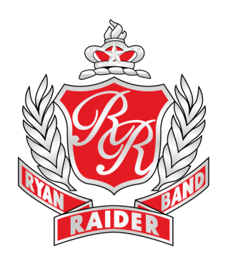

**Play-Off Game #4**

**Saturday, December 8 at 8pm**

**Ryan Raiders vs. Birdville**

**Ford Center at The Star**

**9 Cowboys Way, Frisco, TX 75034**

**\*Schedule Subject To Change\***

We will wear our Blue Raider Band “Home of Champions” Shirts, Raider Band Shorts, Black Drill Masters Marching Shoes, and High Black Socks. Long hair up in a bun and no jewelry.

Please eat dinner before you arrive. Dinner will not be provided. Bandwiches will be available after the game.

**Halftime Performance:** Spirit Show – The Horse, Let It Snow!, and Fight Song (Double Rs) AND HandClap (Strutter Tune)

**Band Itinerary:**

|  |  |
| --- | --- |
| 4:30pm | Band Hall Open. |
| 5:00pm | Inspection. |
| 5:15pm | Load Buses. |
| 5:30pm | Depart RHS. |
| 6:30pm | Arrive at Ford Center at The Star |
| 8:00pm | Kick-Off… Go Raiders! |
| 11:00pm | Game Over. |
| 11:15pm | Load Buses and Trailer. Get Bandwiches. |
| 11:30pm | Leave Stadium. |
| 12:15pm | Arrive at RHS. (approx.) |

Students, make arrangements to be picked up according to our arrival time.

Let’s have a great football game! GO RAIDERS!

-Mrs. Brown

**Ryan High School**

**“Home of Champions”**

5101 E. McKinney St.

Denton, Texas 76208

Fax 940-369-4960

**Raider Band Website**

www.ryanraiderband.org

**Mary Brown**

Director of Bands

940-369-3079

mbrown@dentonisd.org

**Juan Nuñez**

Associate Director of Bands

940-369-3049

jnunez@dentonisd.org

**Akira Robles**

Director of Percussion

940-369-3078

arobles2@dentonisd.org